THE TITLE OF A SCIENTIFIC ARTICLE SHOULD BE WRITTEN BRIEFLY AND CONCISELY.

(Cambria, 14)

Author 1, Author 2, …., Author 6 (Cambria 10, A maximum of 6 author names)

^{1,2,3}Study Program, Institution Name, Country (Cambria, 10)
^{4,5}Study Program, Institution Name, Country, Negara (Cambria, 10)
⁶Study Program, Institution Name, Country (Cambria, 10)

Author@email.com¹, Author@email.com², …,Author@email.com⁶ (Cambria, 10)

No. Wa:

ABSTRACT
Provide an overview of the research carried out, written fully and clearly. An abstract is written in two languages, the Indonesian language and the English language, entered in 1 paragraph 1 of the space. The abstract contains the foundations of research, such as the purposes, methods and results of research. Abstract must be able to describe how the research carried out can contribute to the development of science in the field of education. Keywords are written under abstract in bold and italic formats and are the substance of the research carried out. The abstract writing format and the keyword, as well as the entire article body, should follow this printable. Number of words in abstract 150 – 250 words in Indonesian. (Cambria, 9)

Keywords: abstract, bold, italic

- INTRODUCTION
The introduction contains the research objectives and the reasons for conducting the research. The main part of an article should begin with an introduction that provides further details about the purpose of the writing/research, motivation, research methods, and findings. The introduction should be relatively non-technical, yet clear enough for readers to understand the contributions of the article.
The template is designed to provide guidance to authors on the format or layout of articles published in Aljabar: Journal of Mathematics Education. Writers must adhere to writing rules, including font type, size, layout, word count, structure, and citation format. What is equally important is that the writing adheres to the Enhanced Spelling System (EYD) of the Indonesian language, using appropriate vocabulary and following.
scientific principles correctly and appropriately. If the article is written in Indonesian, then the article must use correct grammar and has been carefully proofread by a language expert. In addition, the writing must adhere to the ethics of scientific publication. The body of the article, including the bibliography, is written in a single column, as in this template. The first line of the first paragraph after the subheading is not indented (aligned with the subheading). In the following paragraph, the first line is indented by one tab. (0,64 cm). Typing articles will be easier when using Microsoft Word software. Use the page layout menu to determine the paper size used, which is A4, and set the margins or borders for the right, left, top, and bottom using the options. (That is: right 2 cm; left 2 cm; top 3 cm; and bottom 2 cm.). The line spacing is single without any additional space between paragraphs. The font used is Cambria size 12pt.
The writing system consists of an introduction, methods, results, discussion, and conclusion. The introduction contains the reasons for conducting the research supported by a literature review. (theoretical). The introduction section is written to be about 20% of the body of the article. Then, the methods section contains a brief description of the research methods used (approximately 10% of the body of the article). The next section is very important, namely regarding the results and discussion. This section is written to comprise about 65% of the overall article, and the discussion of the research results must refer to previous research findings. The conclusion is written concisely (about 5% of the body of the article) to provide a brief answer to the research problem. Meanwhile, the bibliography is written according to the guidelines issued by the American Psychological Association (APA) Sixth Edition published in 2010.

- RESEARCH METHOD
This section of the methods must explain the research methods used, including the location, timing of the research, and how the procedures were carried out. The tools, materials, media, or research instruments must be explained clearly. If necessary and important, there is an attachment regarding the outline of the instruments or excerpts of the materials used merely to provide examples for the readers. If there are statistical formulas used as part of the research method, it is advisable not to write down formulas that are already commonly used. For example, specific provisions set by the researchers for the purpose of collecting and analyzing research data can be explained in this methods section. Writers are advised to provide references for the methods used.

- RESULTS AND DISCUSSION
The results and discussion should be presented in the same section, clearly and concisely. The discussion section must contain the implications of the research findings, rather than repeating the results section. The results and discussion can be written in the same part to avoid extensive citations.
Figure 1. Bar Chart
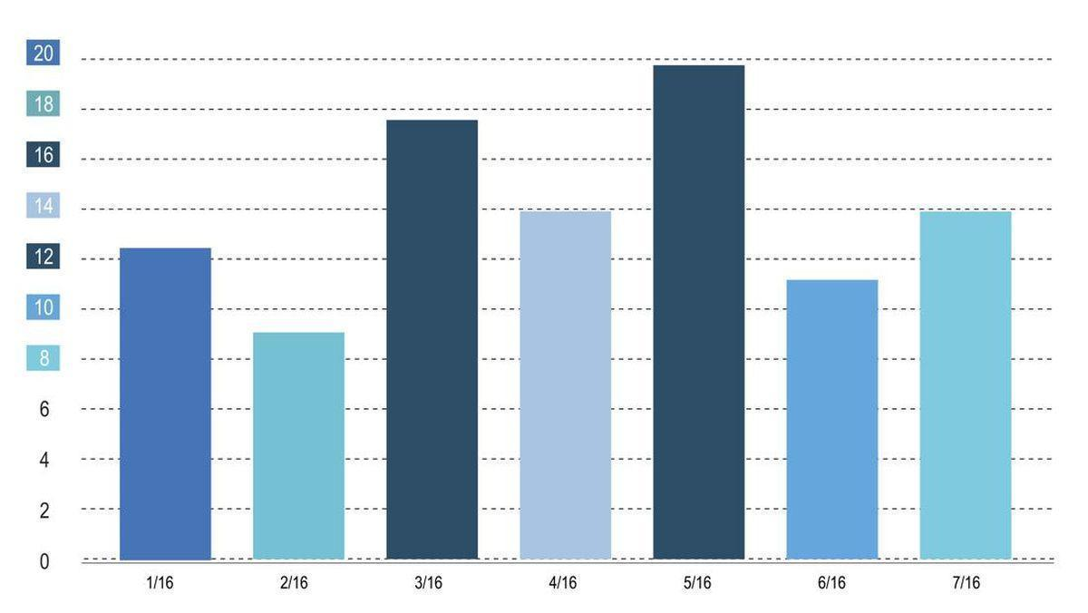

Table 1. Example Format for Writing or Presenting Data in a Table
Name of the Section | Description
Abstract | Abstract
Research Methodology | Research Methodology
Results and Discussion | Results and Discussion
Conclusion and Recommendations | Conclusion and Recommendations
References | References

- CONCLUSION
In conclusion, it should be able to answer the research questions. Some suggestions related to the results can be added. This conclusion and recommendation contain the findings from the conducted research.

- REFERENCES
The bibliography is written at the end of the article in the same font type and size as the body of the article. The bibliography is arranged in alphabetical order. Everything referenced in the article must be included in the bibliography, and everything listed in the bibliography must be cited in the article by indicating what is referenced within the article. This reference uses the American Psychological Association 7th edition citation style. All references must adhere to writing ethics, especially regarding the writing of direct or indirect quotes. This section provides examples of citation writing. Everything in this list can be traced within the body of this article template to study the proper way of writing citations in the text. To make it easier to write references, use software like Mendeley.

REFERENCE LIST
Hidayat, N., & Rostikawati, T. (2018). The Effect of the Scientific Approach with Comic Intelligent Media Support on Students ’ Science Competencies. Journal of Education Review and Research, 1(1), 38–50.
Ningrum, E., Nandi, N., & Sungkawa, D. (2018). The Impact of Local Wisdom-Based Learning Model on Students’ Understanding on the Land Ethic. IOP Conference Series: Earth and Environmental Science, 145(1). https://doi.org/10.1088/1755-1315/145/1/012086
Pourhosein Gilakjani, A., & Sabouri, N. B. (2016). How Can Students Improve Their Reading Comprehension Skill? Journal of Studies in Education, 6(2), 229. https://doi.org/10.5296/jse.v6i2.9201
Lang, H.R. & Evans, D. N. (2006). Models, Strategis, and Methods: For Effective Teaching. New York: Pearson Education, Inc.
Suharsimi, A. (2010). Pengantar Statistik Pendidikan. Bandung: Grafindo

